HandsMen Threads – Customized Salesforce CRM Deployment

**Project Summary**

The HandsMen Threads initiative revolved around architecting a personalized Customer Relationship Management (CRM) solution utilizing Salesforce. The objective was to streamline client interaction workflows, centralize booking operations, and automate internal processes through Salesforce's low-code capabilities such as Flow Builder, Validation Rules, Approval Workflows, and Real-Time Dashboards. The system offers core functionalities like customer data management, appointment scheduling, lead tracking, automatic task generation, and insightful reporting for better decision-making.

**Project Goals**

* Digitize and automate the service booking lifecycle.
* Strengthen client data handling with bespoke Salesforce objects and custom relationships.
* Deploy Flows and Process Builder to eliminate repetitive manual tasks.
* Create actionable dashboards and reports for monitoring business performance.
* Define and enforce user-level permissions to maintain operational security.

**Stage 1: Needs Assessment & Strategic Planning**

**Business Insight Gathering**

The CRM is tailored for businesses offering appointment-based services where managing bookings, tracking clients, and assigning operational duties is critical. Stakeholders expressed the need for a centralized system that handles these processes with minimal manual input.

**Scope & Vision Statement**

* **Inclusions:** Appointment management, service request handling, employee task distribution, customer segmentation, and analytics.
* **Objectives:** Streamline customer journey from booking to feedback while optimizing employee efficiency.

**Data & Security Architecture**

* **Custom Entities:** Appointment__c, Service_Type__c, Review__c
* **Relationships:** Master-Detail (Service_Type__c to Appointment__c), Lookup (Review__c to Appointment__c)
* **Access Control:** Role hierarchy, permission sets for granular control, and security profiles for Admin, Coordinator, and Staff.

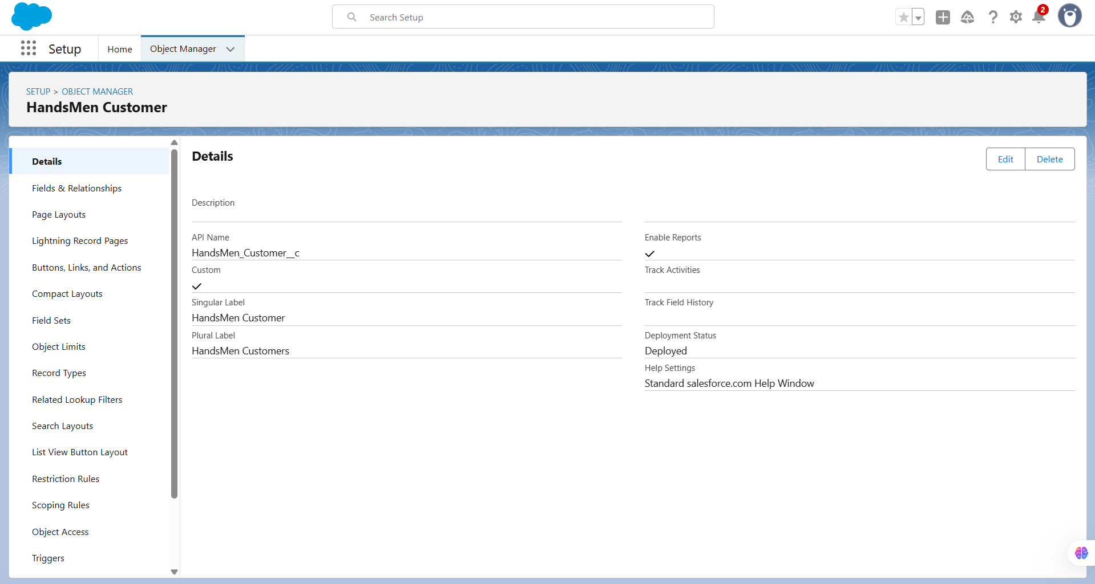

**Stage 2: Salesforce Backend Development & Configurations**

**Environment Setup & DevOps**

* Developer Org provisioned for initial build.
* Metadata tracked for version control and migration via Change Sets.

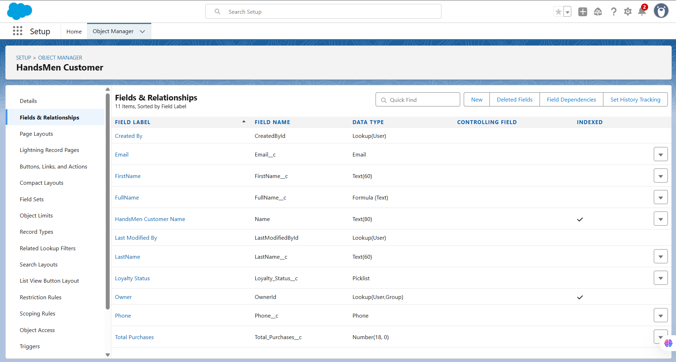 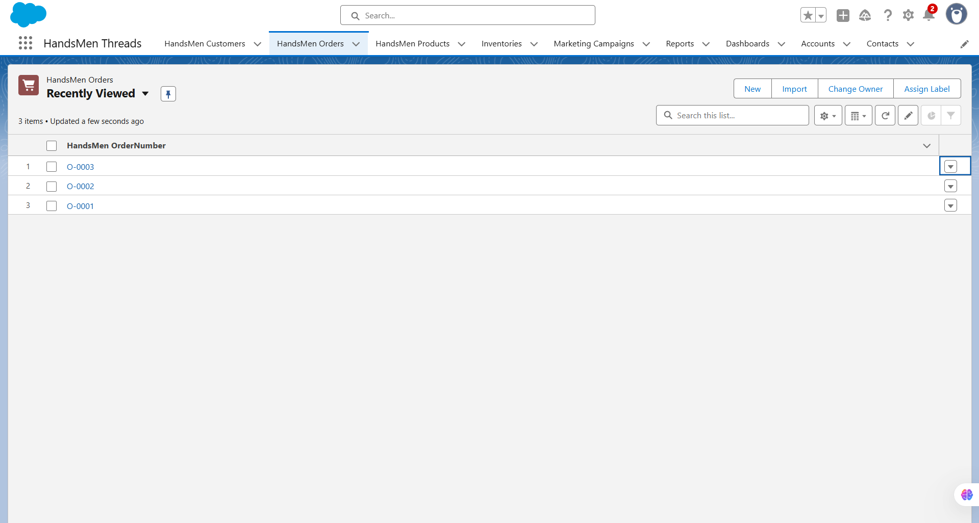 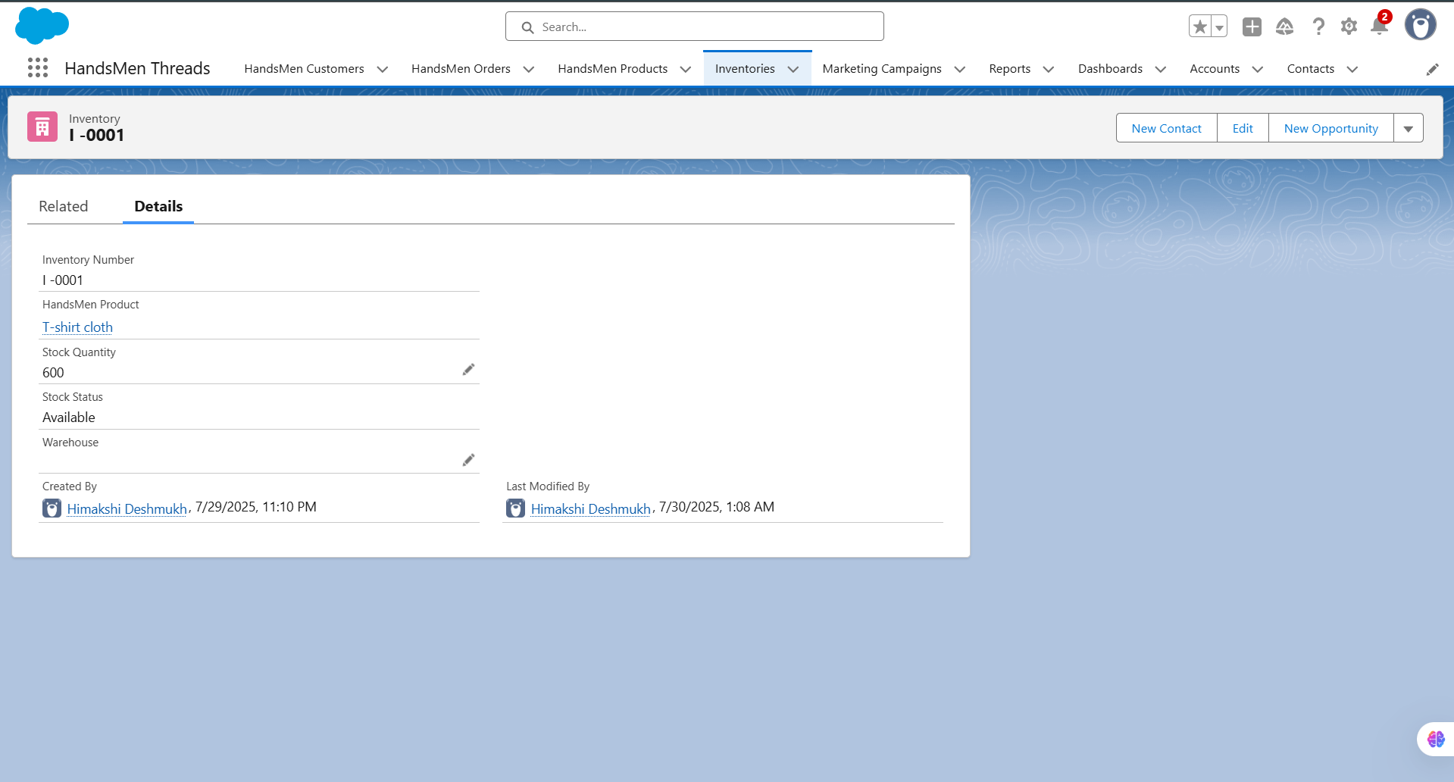 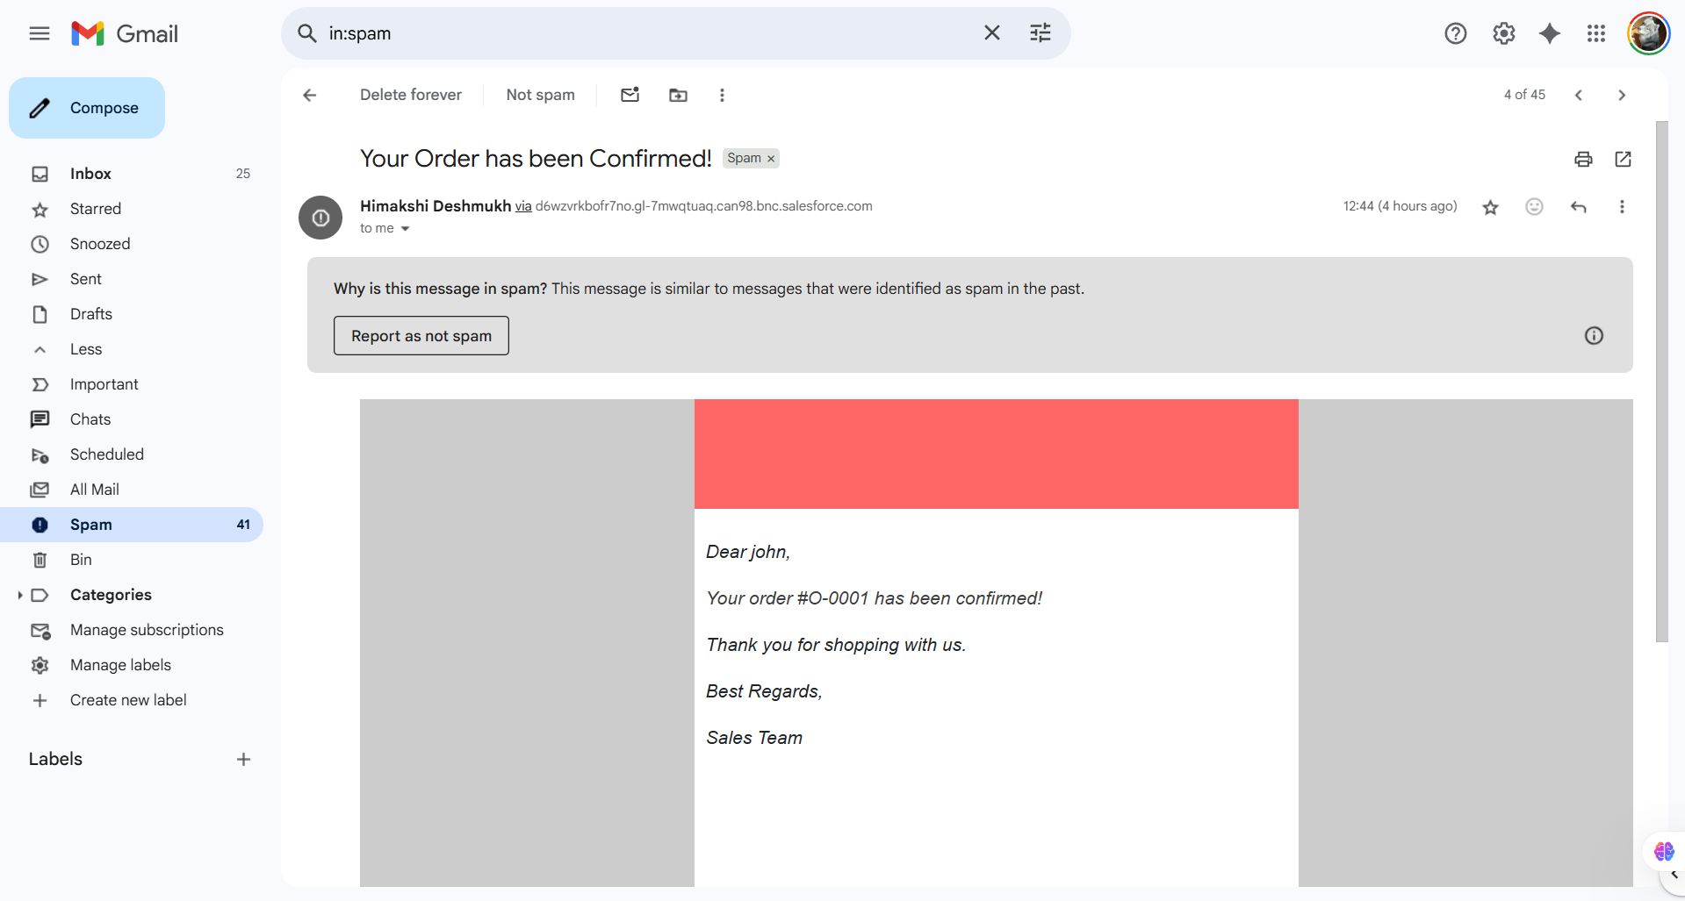

**Customization & Logic Automation**

* Developed Custom Objects: Appointment, Service_Type, Review.
* Implemented custom fields, strict validation rules (e.g., valid contact number, booking date in the future).
* Used Flow Builder to auto-assign internal tasks once appointments are confirmed.
* Booking cancellation and premium service approvals handled via an Approval Process.

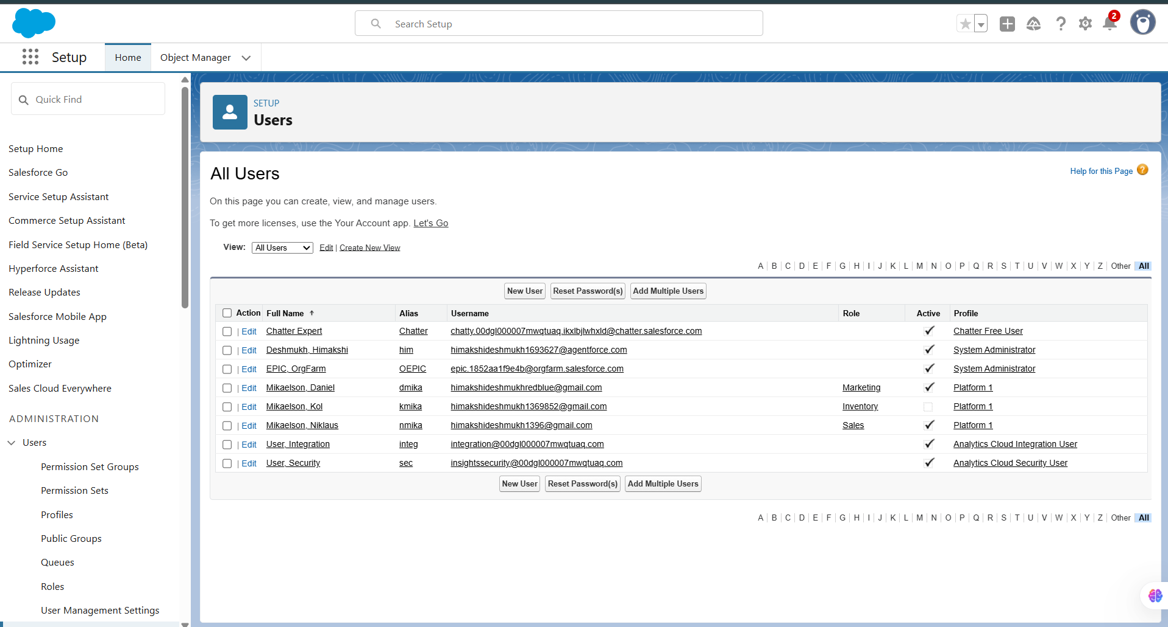

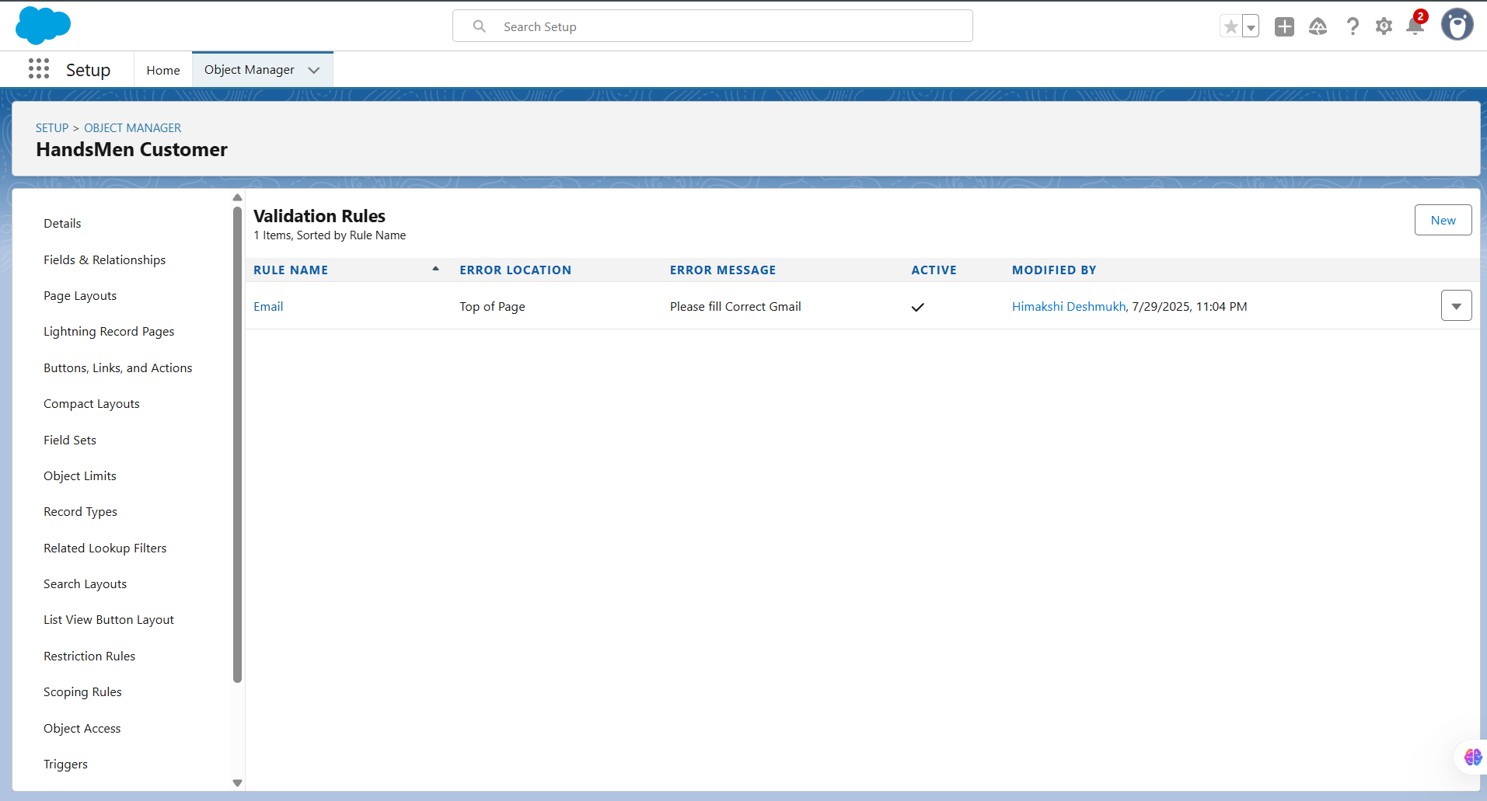

**Apex Implementation**

* Developed triggers to auto-populate related fields and prevent record duplication.
* Used Queueable Apex for bulk notifications (e.g., follow-up reminders).

**Stage 3: Interface Configuration & User Experience Design**

* Created a Lightning App specifically for HandsMen Threads’ operations.
* Used Dynamic Forms for enhanced user input experience.
* Customized page layouts and tabs for intuitive navigation.
* Assigned specific Lightning Pages for Appointment and Review objects.
* Role-based page access and visibility settings configured.
* Reports include “Weekly Appointment Trends” and “Customer Review Ratings.”
* Dashboards track KPIs such as Weekly Revenue, Employee Utilization, and Average Review Score.

*Note: No LWC (Lightning Web Component) development was necessary for this iteration.* 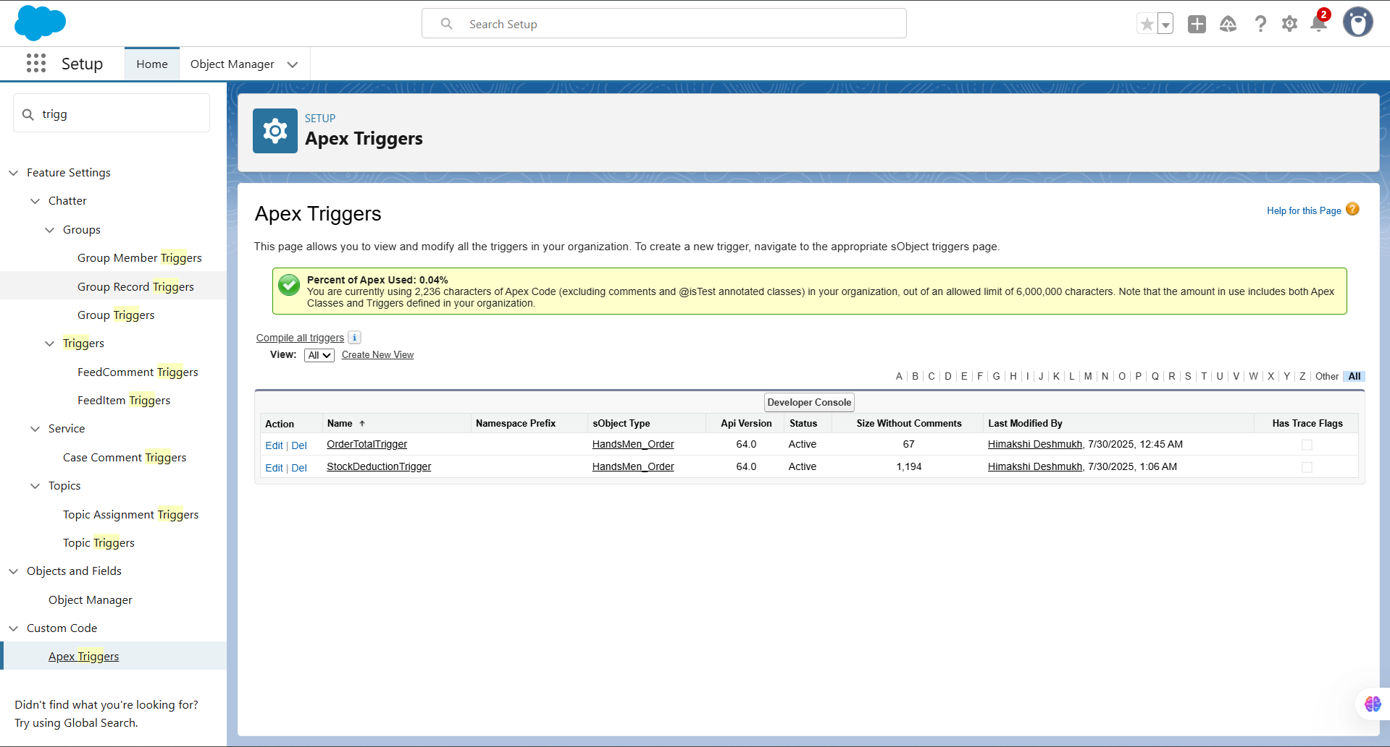

**Stage 4: Data Onboarding, QA & Compliance**

**Data Migration**

* Initial data upload conducted via Data Import Wizard.
* Ensured proper Owner assignments and relationship mapping for historical service data.

**Audit Controls & Validations**

* Enabled Field History Tracking on Appointment and Review records.
* Duplicate prevention mechanisms implemented via Matching Rules for contact emails.

**Security Controls**

* Created customized Profiles for each role.
* Implemented Sharing Rules for cross-department visibility.
* Permission Sets enabled report access for Analysts.

**Testing & Quality Assurance**

* Developed Unit Tests for Apex logic (ensured over 75% code coverage).
* Conducted manual test scenarios including:
  + Booking lifecycle
  + Approval request and status update
  + Flow-triggered task generation
* Collected evidence via screenshots and logs during functional tests. 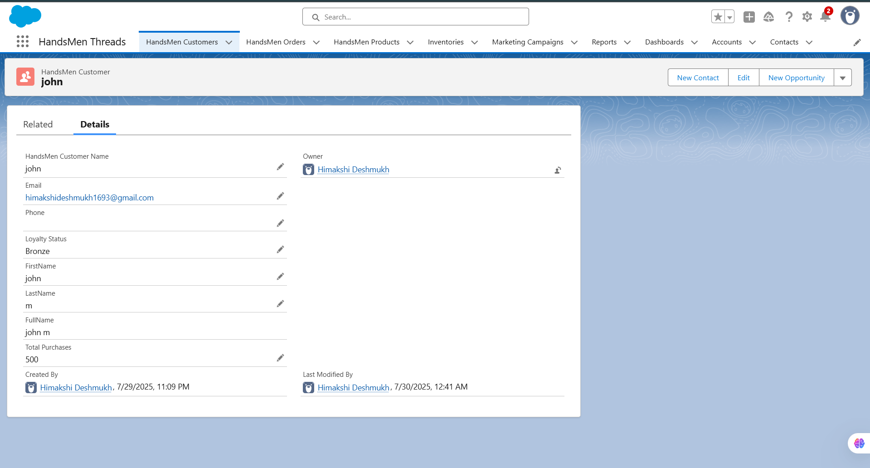

**Stage 5: Go-Live, Knowledge Transfer & Ongoing Support**

**Deployment Methodology**

* Components migrated using Change Sets from sandbox to production.
* Deployment items: Custom Objects, Workflows, Reports, Validation Rules, and Flows.

**Maintenance & Governance**

* Appointed a dedicated Salesforce Administrator for monitoring and support.
* Weekly data backups scheduled for critical objects.
* Failure alerts (e.g., flow errors) routed via automated email notifications.

**Troubleshooting Practices**

* Contextual error messages shown during user input.
* Logged Flow Failures and scheduled task failures routed to Admin mailbox.

**Use Case Illustration**

**Industry Scenario: Men's Tailored Apparel Brand – HandsMen Threads**

1. **Client Signup:** New client registers on the platform, submitting personal and contact details.
2. **Service Customization:** Admin updates the catalog with custom suit packages under Tailored_Package__c.
3. **Appointment Request:** The client books a fitting appointment for a "Premium Suit Package".
4. **Billing Computation:** An Apex Trigger calculates the full service cost based on selections.
5. **Inventory Adjustment:** Inventory object reflects a real-time deduction in fabric stock.
6. **Low Stock Notification:** When fabric availability dips below preset levels, a Flow sends alerts to the procurement team.
7. **Client Loyalty Assessment:** A scheduled Flow scans order history; clients spending over ₹15,000 are tagged as “Elite Members.”
8. **Confirmation Message:** Client receives an automated appointment confirmation and invoice via email.
9. **Engagement Campaign:** Marketing team runs a new collection preview targeting Elite clients using Campaign__c.

**Outcome**

The Salesforce CRM deployed at HandsMen Threads has transformed formerly manual operations into a seamless, tech-enabled experience. It boosts staff productivity, simplifies appointment scheduling, and ensures consistent client engagement. The live analytics and dashboard features empower management with real-time business intelligence.

**Planned Enhancements**

* Integration of AI-driven Lead Qualification via **Einstein Prediction Builder**.
* Chatbot support for real-time appointment scheduling and feedback submission.
* Synchronization with Google Calendar and Outlook for auto-reminders.
* Automated SMS and WhatsApp notifications for appointment confirmations and promotions.

Himakshi Deshmukh